**Running BSQLI:**

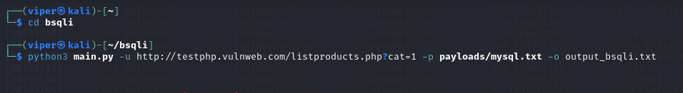

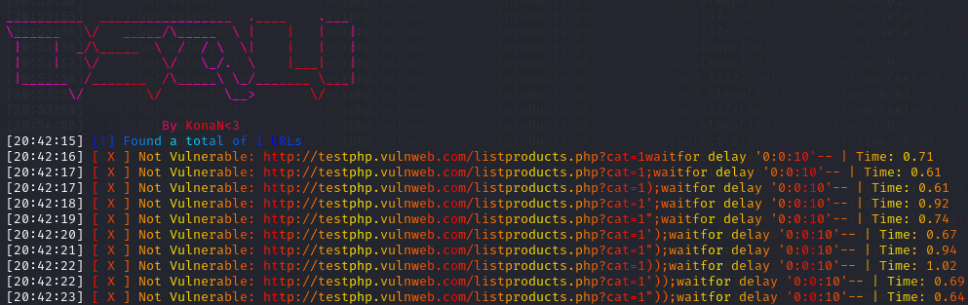

**Vulnerable Path Found:**

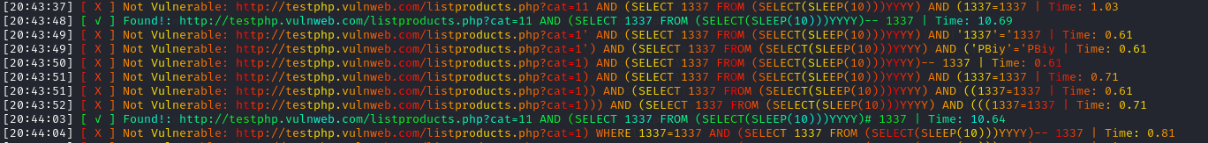

**Output Saved To Text File:**

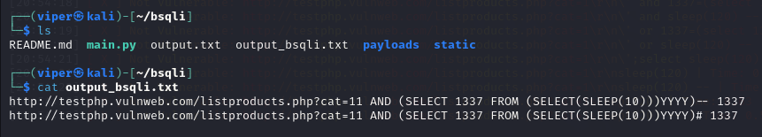

**Open Metasploit:**

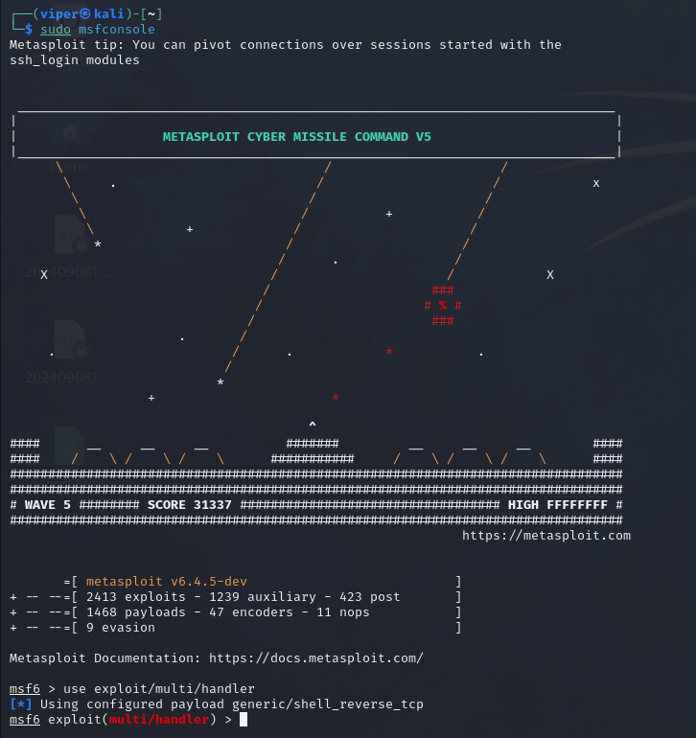

**Start a Listener on Port 4444:**

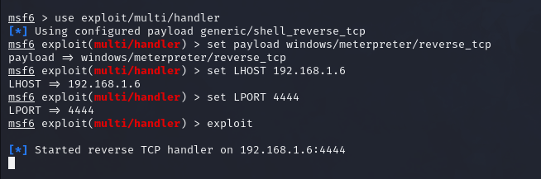

**Create Payload Using msfvenom:**

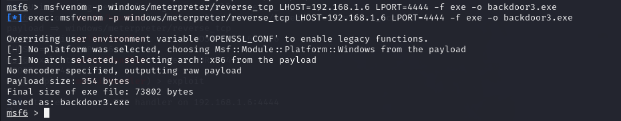

**Start a Apache server it will help in installing backdoor in windows:**

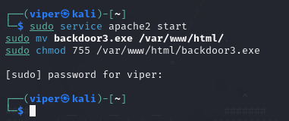

**File Installed in windows:**

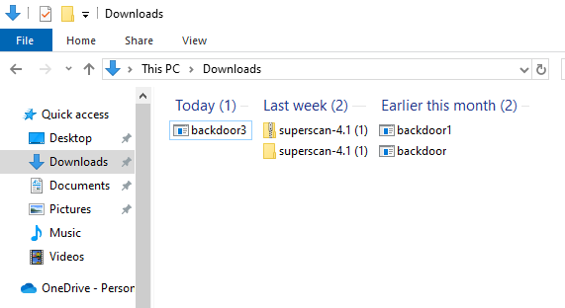

**Got the Meterpreter connection of victim machine:**

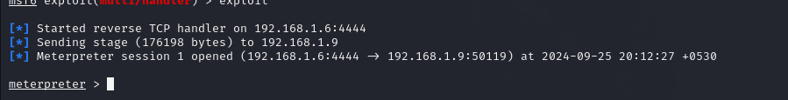

**Sysinfo:**

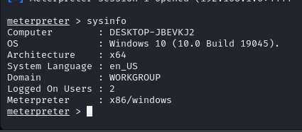

**Create Persistence:**

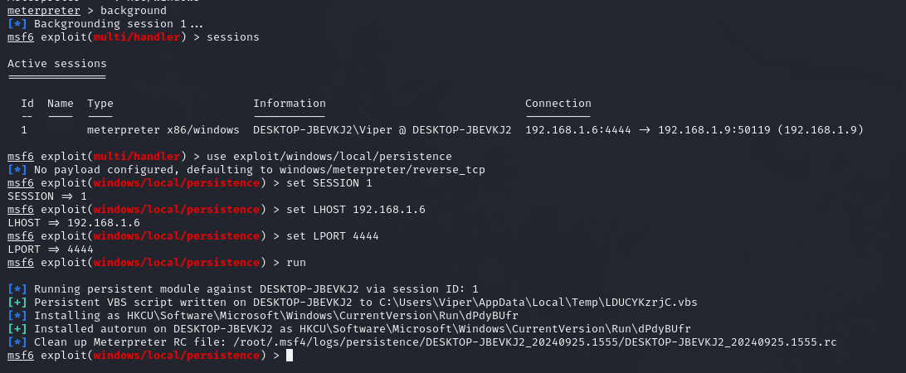

**Start a listner:**

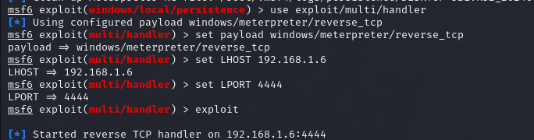

**Reboot Windows machine to get meterpreter connection to check working of persistence:**

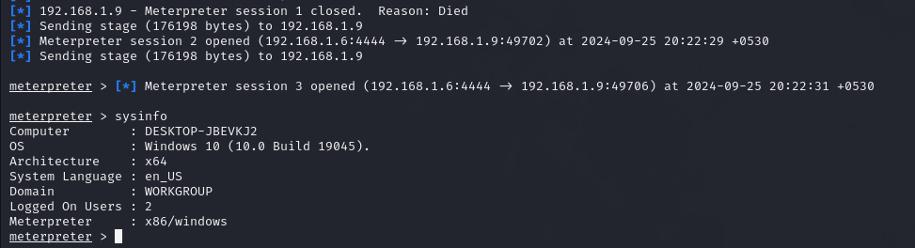

**Ps:**

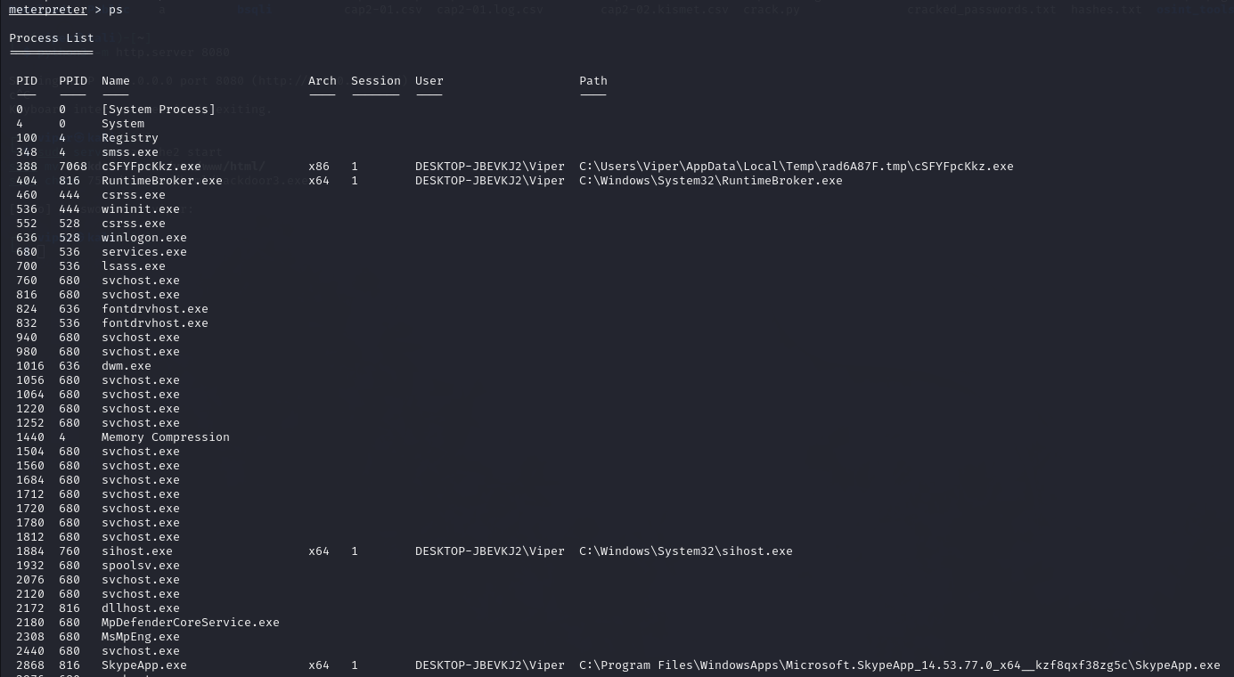

**Downloading files from victim machine:**



